Lauriston Farm Ltd
Five Year Business Plan 2017-2021
(original written January 2017, this update October 2017)

1. Executive Summary
Lauriston Farm is situated on the Blackwater Estuary, close to the village of Goldhanger in Essex, and the farm business operates on 210 acres of farmland and salt marsh. This business plan describes a project to take the last thirteen years of developing the practical application of anthroposophy at Lauriston Farm forward into a Charitable Community Benefit Society (CCBS) in order to;
  - expand the biodynamic farming and conservation work undertaken to increase the outputs in terms of public environmental goods and the resulting farm produce;

  - provide day experiences for adults with mild to moderate learning difficulties to participate in all aspects of the farm including animal care, gardening, wool processing, cooking and sales;

  - diversify and increase the farm based educational opportunities to all ages.

People inspired by the practical application of anthroposophy will lead the project to create a business that stands alone financially to reduce the dependence on agri-environment grant support to cover running costs. There will be a high duty of care to all the people working on the project. A large warmth body will be created around the project generating a supportive atmosphere. The business will be dynamic and respond quickly to adversity and be resilient by having a diverse basket of income streams.
The CCBS is registered with the FCA under Cooperative UK’s model rules. This enabled Lauriston Farm Ltd to run a community share offer from February to May 2017 which raised £30,870 from 138 members confirming Lauriston Farm Ltd as a membership-led organisation run for the benefit of the community it serves. This investment has enabled match funding in the form of a £20,000 grant and £20,000 loan available through Just Growth. We also received a £10,000 grant from Santander, a £4,949 grant from Essex County Council, a £4,000 grant from Tesco and a £14,943 grant from the Essex Association of Local Authorities all of which contributed towards the Social Farming Initiative.
The Higher Tier Countryside Stewardship Agreement started on 1st January 2017 and runs for five years. In August 2017 the new farmer, Andre Kleinjans, and grower, Monique Kleinjans, began full time employment introducing chickens for eggs and the development of new horticultural enterprise initially on one acre to produce field scale vegetables.
The social farming infrastructure was set up in 2018 with a launch event on September 10th and has started to cross subsidise the farm production with two paying co-workers at time of writing. We had originally budgeted on many more at this stage and so the next round of fund raising starting in November 2018 will centre on start up wages for e dedicated staff member for this activity and the creation a new, a large, new all-weather room for workshops. It also will raise funds for the introduction of pigs, accommodation for long term volunteers or apprentices, rainwater harvesting and a bore hole for irrigation and an expansion in the horticultural enterprise. Educational activities will increase with on and off farm biodynamic training, further engagement with local schools and the continued development of a Steiner Parent and Child Group leading onto the founding of an on-farm kindergarten in the future. Within five years any loans will be repaid.

2. The story so far
Evolution of the farm landscape and the SSSI
Lauriston Farm sits on the north coast of the Blackwater Estuary in Essex, a couple of miles east of the small village of Goldhanger - maps can be found in the annex. Human settlement of the area dates back to Neolithic times with the remains of seven Neolithic round houses within four miles of the farm. Until the 1400s and the beginnings of the sea wall, the vast majority of the current holding was salt marsh within which Romans produced salt in an area on the farm today known as a ’Red Hill’ which is now listed as an ancient monument. The Anglo Saxons also used the site for salt production and were well known for grazing the salt marshes with sheep. As the sea wall rose, the salt marsh slowly drained and many salt loving plants adapted to fresh water conditions. These gave rise to an undulating landscape ideal for grazing which retained the profile of the salt marsh and were evocatively named as ‘sea meadows’.
In the 1600s a decoy pond was excavated in one such meadow and was used for trapping migrating wildfowl until the 1850s. In its heyday, 20,000 birds a year were caught and today it is listed as an ancient monument. Towards the end of the 1800s the then owner of the farm, a Mr Laurie, excavated gravel from a shingle spit on the seaward side of the wall and this is where the farm’s current name, Lauriston, came from.
The sea meadows existed until 1972 at which time agricultural improvement grants were available to flatten the marshes, lay drainage pipes and ditches thus converting them to arable crop production. However, a 30-acre parcel of sea meadow escaped the arable conversion and it now exists as a rare glimpse of a landscape that evolved over almost six hundred years. In addition, despite the stone excavations and the sea wall development, 25 acres of salt marsh still exists.
Protection of these habitats began in the 1950s under the 1949 National Parks and Access to the Countryside Act and later as SSSI under the 1981 Wildlife and Countryside Act. By the end of the 1980’s the improved fields were partly cropped and partly used for set-aside.
Involvement of the Christy Family
In 1987 Robert and Marion Christy moved from the Blackwater Estuary market town of Maldon to the farmhouse and seven acres of Lauriston Farm. It was the peace and tranquillity of the environment that the house was located in that attracted them. The 260 acres of land associated with the house remained in the ownership of the previous house owner who continued to farm it with arable cropping and fattening of beef steers. Five years later, the farmer decided to sell this land and concentrate on his new holding near Colchester which immediately generated interest from industrial developers. Plans for industrial units, a sawmill and even a light aircraft landing strip were put forward and this prompted Robert and Marion to take the courageous step of raising a mortgage to purchase the farm land.
The purchase was completed in 1993 and by the end of the following year 122 acres of the improved arable land under cereals and set-aside were formally notified as SSSI. Permanent pasture was recreated on the cropped part in 1995 and the land was entered into the Essex Coast ESA scheme with a Section 15 management agreement. The sea meadow mentioned earlier was grazed with cattle by the previous owner until the foot and mouth outbreak of 2001. The other fields were topped to provide overwintering grounds for Brent Geese and other waders.
This meant that 180 of the 260 acres were now designated as SSSI – a great relief to Robert and Marion and a wonderful gesture to the flora and fauna of the Blackwater Estuary.
In 2003, Robert and Marion had to sell 135 acres, leaving a total of 125 acres in their ownership, with no mortgage, of which only 15 acres are not SSSI.
The following year, their son Spencer moved to the farm to start developing his own farm business and after two years enrolled the entire 125 acres into the High Level Stewardship Scheme with organic conversion. The holding was prepared for livestock with significant investment in fences, gates, water troughs and livestock handling facilities before Shetland cattle and North Ronaldsay sheep arrived. Some of the pasture had not been grazed for forty years and within a year the insect life began to form and the following year the bird life started to return.
In addition, 4000 hedging plants were planted, a new wildlife pond installed and in 2007 the first biodynamic field sprays were applied. In 2008, Spencer started renting 85 acres of the improved pasture SSSI previously owned by Robert and Marion. Organic certification was completed in the same year with biodynamic certification being achieved in 2010. All the land drains have now been removed so the fields can hold water over winter like the sea meadows and provide habitat for ground nesting birds and some two thousand overwintering Brent Geese, other wildfowl and waders.
The current situation
From this small beginning the holding now has a herd of 30 cattle, a flock of 270 sheep, five natural honey bee colonies and hosts around 300 visitors each year for education farm walks looking into the conservation work being undertaken.
In 2012 the farm was runner up in the Essex FWAG Farm Conservation Award and has been used by Natural England for farmer visits as a good example of organic pasture managed for conservation.
Further funding has enabled the building of three meeting rooms, a disabled toilet block and wheelchair access to over one kilometre of the farm. In the financial year 2015/16 the sole trader business made a profit of a little over £4,000 with a positive balance sheet of £31,000. This supports Spencer with his parents receiving the Single Payment and other access payments. Some photographs of the farm can be seen in the annex.
The meat is sold locally with sheepskins and other wool based products sold more widely often through the farm’s website and Etsy. There are currently about a dozen volunteers who help with all day to day aspects of the farm with Robert and Marion also involved quite extensively.
The farm has taken local school students for eight years and in the last four years social farming projects have begun with the Department of Works and Pensions and long term unemployed people as well as individuals suffering from mental illnesses.
For three years the farm has run biodynamic workshops and also a Steiner Parent and Child Group. A business plan has been written for the development of a Steiner kindergarten on the farm.

The following mission statement for the farm was written in 2013 – it summarises what the farm has enabled and will continue to enable:
To create and maintain
A safe and protective environment
For the evolution of
The spiritual hierarchies
The four kingdoms of nature and
The elemental world
Through the practical application of
Anthroposophy

The farm is now at a point where more people are getting involved to expand the existing enterprises and fresh injections of capital are being sought for the development of new enterprises. Since October 2014 work has been under way to produce a future vision for the farm which encompasses farm succession.

3. The Future Vision
The overall vision for the future is to protect and improve the biodiversity of the farmland and secure the farm’s future by increasing and diversifying production and using social farming to cross subsidise food and farming activities. This blend of different activities will make the whole enterprise viable in the long term. It will build on the pioneering foundations of the work undertaken by Spencer Christy as a sole trader and broaden it out to a more inclusive, non-traditional community orientated business through the Charitable Community Benefit Society model. Putting the farm business into community ownership was the first step in addressing the issue of farm succession and gives a vehicle to secure the farm and the land in perpetuity for the benefit of the community.
Biodiversity will remain centre to farm’s activities and the wild estuarine flora and fauna will be supported together with many other threatened species including the honey bee. The number of habitats will be increased and existing habitats enhanced through careful management. It will be an oasis of protection to the most threatened farmland wildlife species and a beacon of good environmental practice in the area.
The farm will continue to practice biodynamic principles and ensure certification is maintained every year. The farming activity will expand into pigs, chickens, crops and enlarge the cattle herd to create a more self-sustaining farm organism. We shall endeavour to become a centre of biodynamic excellence and share our experience through workshops, training days and the land based diploma programme.
The farm will also develop further its social farming strand to help make the farm viable and resilient. By this we mean the farm remains intrinsically a working farm but invites people to participate in the day to day activities of the farm, leading to social outcomes such as:
- Economic participation and integration of vulnerable or disadvantaged groups
- Provision of new skills and self-appreciation
- Opportunities for rural employment
The farm will eventually provide thirty day placements a week to give adults with mild to moderate learning difficulties a chance to work alongside the staff undertaking the day to day activities that the farm requires.
Educational opportunities will be available to all ages using the Steiner Waldorf principles and the rich mix of natural and farmed habitats found at Lauriston. These will remain small scale and person centred to allow each participant to express their individuality as fully as possible. The farm will become a hub for anthroposophical understanding and learning about sustainable practices of farming and gardening as well as cookery and traditional crafts.
The Charitable Community Benefit Society has a board of trustees comprising two existing volunteers with relevant experience, two trustees from outside the farm and the Farm Director as an ex-officio member of the Board. The Board meets six times a year as well as holding the AGM and any other general meetings of members. Advisors to the Board are co-opted as required.
Initially there will be six paid members of staff, three full-time and three part-time delivering this vision. These include a farm director, a biodynamic farmer, a biodynamic gardener, a biodynamic apprentice, a social farming coordinator and a craft coordinator. There will be additional roles for volunteers supporting these paid roles. An accountant has already been found.
How the planned activities will contribute to our mission
To achieve the farm’s mission, the practical application of Anthroposophy is required. This is already reflected in the biodynamic method of agriculture and through the structuring of educational activities in accordance with the Steiner/Waldorf method. This then requires some individuals to have prior training and experience in these methods.
The prominence given to nature conservation creates a rich, diverse flora and fauna which, together with the biodynamic preparations, produces a warm and tranquil atmosphere to the farm. From this, individuals have experienced great therapeutic benefits, often connecting with childhood memories or just finding a quite space to sit and listen to nature.
Whilst there is a wide diversity of core activities, they are all on a small scale and generally require hand work instead of machine work. Thus we are aiming to work on a human scale with minimal use of machines and electricity. This direct human involvement in caring for the soil, the plants, the animals and each other as human beings is of great interest to the spiritual world, enabling these beings to evolve at the same time.
Anthroposophy is not dogmatic, instead it flourishes in a setting with a variety of points of view which will be achieved as the farm opens up to more people on a daily basis and through membership of the CCBS. There will be the opportunity for individuals to explore more deeply the work of Rudolf Steiner through a study group, guest speakers and workshops.
Choice of legal structure
The Charitable aspect of the legal structure was chosen as the core activities of the farm - nature conservation, community involvement, education and therapeutic care - are all charitable in nature. Outwardly and inwardly it will give an immediate and clear understanding of the nature of the work being undertaken with the assurance that we are operating solely on a not-for-profit basis. The requirement of a Board separate from employees is very useful and healthy in ensuring the society keeps to its objectives. It also gives an extra layer of help in resolving problems and bringing fresh ideas and inputs to the organisation.
The Community Benefit Society model fits perfectly with the desire of the farm to open up more and reach out into the local community and further afield, developing a substantial body of warmth around the day to day activities. The equality in voting is important to the farm and the balance between being responsible to the farm but also the members, wherever they live, feels a healthy and freeing gesture. We hope the structure enables those hundreds of people who have visited and/or traded with the farm over the last thirteen years to deepen their relationship to our work.
Lauriston Farm Ltd was formally registered with the FCA as a Charitable CBS under Cooperative UK’s model rules with two changes on February 1st 2017. The charitable objects enshrined in Lauriston’s rules are as follows.
“The objects of the Society shall be to carry on any business for the benefit of the community by undertaking wholly charitable activities that are based on the principles, methods and practice of anthroposophy as initiated by Dr. Rudolf Steiner (as summarised in the Appendix to these Rules), in particular but not limited to the following:

(a) By advancing the education of people with a learning disability, and other people deemed to be in need, by the establishment and operation of a farm, that provides training and farm based educational facilities with the object of improving the conditions of life of the beneficiaries.

(b) By relieving sickness, promoting and advancing good health, providing care and support to people with a learning disability and other people deemed to be in need.

(c) By furthering the conservation maintenance and protection of the farm’s wildlife, its habitats and its historical, archaeological and scientific interest.

The Society shall be owned and controlled by its Members on a fair and equitable basis.”

Relationship Between Lauriston Farm Limited and the Landowners
Lauriston Farm Limited CCBS are entering into a License with Robert and Marion Christy, the landowners, to rent the land and buildings known as Lauriston Farm. Initially this will be for a five year period with a review after three years to establish its continuation for a further five years. The license will state the agricultural activities the CCBS are required and permitted to undertake, an access agreement covering permitted use of the site, the responsibilities of both parties, what to do in the event of a dispute and an inventory of the site. A copy of the license will be held by all parties as well as with a solicitor. To ensure good co-operation between the two parties the Board of the CCBS will always have a representative of the landowners on it.
The Society will also benefit from an existing five year rolling grazing license held by Spencer Christy for eighty five acres of SSSI grassland owned by the Blackwater Wildfowlers Association.

4. Foundations of the Business
There are seven inter-dependent strands to the business:
- Biodynamic livestock and conservation
- Biodynamic crop production
- Wool processing
- Cookery
- Social farming
- Education
- Natural bee guardianship/Demeter hive management
This section looks at each one of these activities to define how it fits within the overall farm operation, its growth potential, where investment is needed to deliver that growth, and how that investment will contribute to the viability of the farm.
4.1 Biodynamic Livestock and Conservation
The area of land managed by Lauriston Farm Ltd is currently 210 acres, all of which has been certified to Demeter (Biodynamic) standards, which covers all the organic standards as well, since 2010. The certifying body is the Biodynamic Agricultural Association (BDAA). This farming method is an ideal fit for conservation farming as required by the Site of Special Scientific Interest, Special Area of Conservation, international wetlands RAMSAR site and Historic England designations which cover over 80% of the total area and for the remaining non-designated 20%.
The aim of the agriculture system at the farm is to protect the habitats that make up most of the land. This includes providing nesting for estuarine birds (target species are snipe, lapwing, curlew and redshank) and for overwintering waders and waterfowl including some two thousand Brent geese. To achieve this, 30 rare breed Shetland cattle and 250 North Ronaldsay sheep are used with participation in the ten year (2006-2016) High Level Environmental Stewardship scheme from Natural England giving guidelines on detailed management prescriptions. These include water management, hedgerows and trees.
This activity forms the bedrock of Lauriston Farm Limited and, aside from the environmental benefits, outputs of beef, lamb, hay, compost, biodynamic preparations, educational walks, wool, training, employment, volunteering and therapeutic life experiences all come.
Potential for growth
Lauriston Farm has been accepted into the five year (2017-2021) Countryside Stewardship Higher Tier scheme to cover all existing work and increase the farm’s habitats through scrub creation over three acres and improving the twenty five acres of saltmarsh by introducing sheep grazing. There is also an extensive hedging and tree planting programme as well as payments for social farming visits.
There is the opportunity to increase the cattle herd from the current level of 30 animals to 45. This will bring an enhanced grassland habitat for target species, produce 50% more compost and nearly double the beef sales.
A three and a half acre area of low conservation value is to be put into pig production with the introduction of one sow and one boar from of rare breed Berkshire pigs. The aim is to produce two litters per year and for the animals to be fed from farm crops to enable the meat to be sold with Demeter (Biodynamic) certification. This will require the development of an outdoor rotation of cropping for the pigs to ‘graze’.
The one acre woodland planted in 1987 by Robert and Marion will be home to rare breed Ixworth hens. The farm has used this breed on a very small scale for over five years as they are good egg and meat producers and an increase to forty hens with five cockerels is planned with sufficient feed coming from the farm to enable Demeter (Biodynamic) certification of eggs and meat.
Required investment
Investment is needed to increase the productivity of the farming system. This comes in the form of a second hand four wheel drive tractor with loader and various implements (bale spike, forks, bucket, muck grapple, trailer). This will enable a reduction in the use of contractors and improve the timing of operations. As production increases, a small refrigerated van with diesel engine for delivery would enable larger quantities of meat to be transported greater distances.
For the pigs, one sow and one boar are needed plus two pig arks with drinkers, permanent and electric fencing and modifications (windows and drainage) to the farrowing house. A conservative estimate of achieving fifty kilograms of butchered meat per animals and charging £6/kg for it gives a turnover of £300 per pig and with two litters per year giving twenty piglets in total gives a turnover of £6,000 per year. Feed costs need to be established as we aim to produce the feed from our own crops.
The chicken expansion requires five houses with drinking and feed troughs, electric netting, purchase of two cockerels and twenty hens, twenty bantam hens and a supplementary hatching unit. Fifty table birds a year at £20 each plus ten dozen eggs for thirty weeks yields a turnover of £2,200. Feed costs need to be established as we aim to produce the feed from our own crops.
4.2 Biodynamic Crop Production
There is currently a wheelchair accessible vegetable and fruit garden with twelve raised beds and two poly tunnels measuring ten foot by thirty foot. This produces basic seasonal vegetables on a small scale for the current farm workers and volunteers to consume. Previously, Spencer Christy had run a small box scheme for the local village and sold vegetables weekly at a market in Maldon.
Potential for growth
The garden sits in a half acre field and there is the potential to produce on most of the area and put another larger poly tunnel up. In addition, there is two and a half acres of low grade conservation land for the growing of field scale vegetables, seeds for the Seed Co-Operative CBS, flowers for the Shrill Carder Bee and crops for the pig and chicken feeds. Enquiries have already been put out locally for an additional 25 acres of rotational cropping land to further expand these activities.
Required investment
Investment is needed for purchase one large poly tunnel to increase the variety and quantity of covered crops grown. Basic cultivation implements are required – rotovator, seed drill and roller. A small cold store would enable produce to be stored for use over winter.
4.3 Wool Processing
There are currently some two hundred and forty North Ronaldsay sheep on the farm which yields approximately two hundred and fifty kilograms of raw fleece each year. Half of this is processed into knitting yarn by the Natural Fibre Company in Cornwall to organic standards and this is sold locally, via the website and through Etsy. The other half is held back for cleaning, carding, spinning and weaving on the farm.
Potential for growth
New products to be sold are raw fleece, washed fleece and washed and carded fleece. We have experimented with weaving the raw fleece to good effect and this produces table mats, wall hangings and small rugs. There is also the desire to produce ‘Lauriston Tweed’ which could be woven at the farm probably from yarn spun at the Natural Fibre Company. The processing of the wool on the farm needs cross-subsidisation from social farming.
Required investment
Investment is needed for the purchase of two large sinks for washing fleeces, two drum carders, three knitters looms with stands. This will enable the social farming days to operate with six participants and this will contribute to the development of the tweed and other items for sale.
4.4 Cookery
Currently farm produce is processed by Marion Christy in her kitchen on a small scale. Daily cooking for lunches for the staff is shared between herself, Spencer, Andy and the volunteers. Farm produce is used as much as possible as well as that bought from other local farms. Supermarket ingredients are organic as far as possible.
Potential for growth
Increase production of jams, chutneys, cakes and pies to Demeter and organic standards and the provision of daily lunches for all workers on the farm each day. This activity lends itself very strongly to social farming.
Required investment
The farm kitchen will be upgraded to food hygiene standards by mid October 2017.
4.5 Social Farming
Since 2007, the farm has hosted 14-16 year old students from the Maldon Plume Academy on work experience placements for one or two days a week during term time. They work closely with the farmer and learn many skills and normally initiate their own project in their second year on the farm.
Over 2014 and 2015, for nine months the farm hosted up to twenty local long-term unemployed people two days a week as part of a DWP project to re-socialise the participants. A smaller group continued to volunteer on the farm and at time of writing two still come weekly. There were many positive outcomes from this project.
In addition, there have also been long-term volunteers attending with mental health issues, depression and anxiety, both of whom have now been able taken on more responsibility in their own lives. There have also been a number of charities visit over the years and the farm has often been categorised as a setting offering tranquillity.
Through the Higher Level Stewardship Scheme, funding enabled the building of three meeting rooms, full kitchen facilities, disabled access toilets and hand washing facilities, raised vegetable beds for wheelchair gardening, one kilometre of decking paths round the farm and a concrete are for offloading wheelchairs.
Potential for growth
All the previous operations described will integrate an element of social farming within their work. This means that for one day a week the person responsible for each operation will host six adults with mild to moderate learning difficulties together with another member of Lauriston’s staff. The day’s tasks will be organised in such a way that there is meaningful work for everyone and these will only be changed from week to week if they are not appropriate. This repetition of activity will enable the participants to learn a skill and over time maybe undertake it with less supervision, thus increasing their self- confidence and independence. All the tasks will be real in the sense that they contribute to the daily work required on the farm.
As a major area of growth, we are aiming to offer thirty day places a week with six people per day attending. Each day will focus on one of the farm operations but this can move a little as we discover where the most interest is. Using their personalised care budgets, each participant will pay £70 per day for the experience and this will include lunch and local transport. We are aiming to have all the places filled by March of 2018.
A second area will be engaging with charities associated with mental health problems. The farm will offer the space for two or three people to experience the tranquillity and peacefulness of the farm whilst undergoing therapy as required.
Required investment
The increased level of human and commercial activity will require an investment in physical infrastructure. A new office space will be created and equipped with a modern computer, photocopier/printer/scanner, telephone and internet. A new ‘boot/changing/tea break room’ will be created in front of the existing toilet block. The space above this and the existing kitchen will then be enclosed to create a large heritage educational room. This can include the larger looms for creating the Lauriston Tweed and storage of other materials. Finally, a new, larger meeting room for lunches and farm visits will be built to link to the food quality kitchen.
To assist with participation in social farming an eight person people carrier will be needed for transporting participants to the farm as it is located one mile off the main road. Buses do stop on the main road and others are only a two mile journey away. It also allows the farm to collect people from their houses for a charge if they are in need of such a service. It is envisaged that this vehicle will be leased for two years initially.
In addition to these physical items, there will need to be an investment in staff wages in year one to assist with the start up. This centres on start up wages for one year for the social farming coordinator.
There are also various start-up costs such as insurance, risk assessments, DBS checks, training, creation of the CCBS, marketing of the project and costs associated with running a membership share offer for the CCBS.
4.6 Education
Over the last ten years the farm has successfully run a weekly Parent and Child Group, developed a sound business plan for a Steiner Kindergarten on the farm, hosted pupils from the Plume Academy in Maldon, undertaken some two hundred educational farm walks, run various farm related workshops (including crafts and honey bees) and written and delivered a One Day and Seven Day Introduction to Biodynamics course. All of these activities follow anthroposophical ideas also known as Waldorf education.
Potential for growth
There is the scope for running two Seven Day biodynamic courses per year, reintroducing the Parent and Child Group, starting a ‘Farm Kids’ program for seven to fourteen year olds, expanding the range of workshops we offer and putting the kindergarten business plan into reality. We will also offer a Biodynamic Apprentice place, now known as a Land Based Diploma Student.
Required investment
The investments outlined in the other operations of the farm will contribute to the delivery of the education mentioned above. We are not seeking funding at this stage for the kindergarten.
4.7 Natural Bee Guardianship/Demeter Hive Management
The farm has had six honey bee hives on it since 2007. After one year of using conventional methods of hive management they were all physically changed to embrace the Biodynamic Production Standards for honey bee hives. After this a close working relationship developed with the Natural Beekeeping Trust (NBKT) and since 2012 no honey has been harvested aside for medicinal purposes. Spencer Christy of Lauriston Farm is a listed swarm collector for the local area and has run NBKT workshops on the farm as well given talk on Demeter/Natural Bee Guardianship to local gardening and beekeeping groups. The gardens have been planted up to more honey bee friendly plants.
Potential for growth
A two area has been set aside for many more bee hives and there is the desire to integrate more bee flowers into the hedgerows to provide food in the winter months. The farm has permission to build Sun Hives and there is a plan to do this as a social farming activity and also for people wanting to build their own hives and then have swarm placed in it either from the farm or from the locality.
Required investment
Investment is needed in the supply of plants for the farm and the setting up of Sun Hive making facility in the craft room. Participation in honey-bee workshops has been very high and often yields other sales of farm produce which can lead into further investment in the honey bees and when the honey bees are healthy, the whole farm is healthy.
5. Operations
This section explains how the farm will be run, and by whom, and how we intend to integrate the work streams.
Biodynamic Livestock and Conservation
There are currently two employees involved in this enterprise.
Andre Kleinjans has over thirty five years of biodynamic farming experience and is responsible for the biodynamic preparations, the cattle herd, the new chicken houses, basic animal husbandry tasks and associated capital works such as fencing and water troughs and assisting with the pigs and sheep.
Spencer Christy, Farm Director, will oversee the management of the sheep and assist with the introduction of pigs and cover holidays for other staff. He is also responsible for how the habitat is managed and created.
Andre will host the livestock social farming day.
Biodynamic Crop Production
Monique Kleinjans-Penning has over thirty five years of experience in biodynamic horticulture and will run the one and half acres of vegetable growing as well as the Celestial Garden.
Andre will assist with the vegetable growing and crop production as will long term volunteers and also daily volunteers.
Monique will host the vegetable social farming day with help from Spencer.
Wool processing
Lois Gardner and Sally Ure Reid will run this activity with assistance from a variety of local crafters with expertise in a variety of fields. Sally is also leading the project to create Lauriston Tweed. Lois hosts the social farming craft day.
Cookery
Monique will have overall responsibility for the kitchen, managing the supply of goods into and setting the weekly cooking rota. A cook will be hired for daily lunches and running the cookery workshop.
Social farming
Overseeing the start-up of the social farming initiative will be Spencer Christy (Farm Director), developing policies, risk assessments, health and safety and other legal documents required and also focus on the infrastructure. There will be meetings with potential participants and other relevant organisations to promote the initiative and attract participants. Sally Ure Reid will also contribute to this process as she has developed many useful contacts.
Each farm day leader will be asked to design one day a week for this initiative keeping the day within the normal tasks performed on the farm. These will be reviewed regularly and adapted as required.
Education
Spencer Christy leads the Seven Day Biodynamic Course with the help of guest speakers and would co-ordinate the land based diploma student. Sally Ure Reid organises craft workshops and training programs. All staff, volunteers and Board members contribute to the general workshop program. Spencer is in conversation with a trained Steiner teacher to re-establish the Parent and Child Group starting in Spring 2019 and develop the kindergarten project.
Natural Bee Guardianship/Demeter Hive Management
Spencer currently looks after the bee hives but the whole farm team will help especially with the cultivation of bee plants crops.

6. Marketing
In this section we explain, for each strand of the business, our marketing strategy, evidence of the markets that already exist and those we intend to develop.
Biodynamic Livestock and Conservation
The meat is advertised on the farm’s website and by direct marketing to existing customers. The new membership of some 138 individuals will generate new customers and the members will have first ‘shout’ on all the farm produce. For new customers, the best marketing is to allow people to see the farm and this is done through having an open door and the educational farm tours. Other marketing occurs through Facebook, trade organisations and local shows. There will be activities for members of the CCBS which will involve sampling the farm’s produce. There is the possibility that a Food Assembly is to be established in Chelmsford.
There is already a reliable local customer base and they will likely take the pork, chicken and eggs as well. There is a very high demand locally for organic chicken meat and previously with one hundred laying birds all eggs were sold without any difficulty. The additional beef will likely need a local restaurant or pub and we have previously been successful in achieving these connections. There is an emphasis on keeping sales local but there is always a good demand for Demeter produce in London and this is under one hour away from the farm. Attending local markets will be another useful outlet.
Biodynamic Crop Production
The vegetable growing will aim to produce for the whole year for all the daily lunches and produce a small (£10) box of vegetables for thirty members for thirty weeks of the year. The cropping will be used within the farm for animal feed. Produce will also be processed using the new food hygiene compliant kitchen.
Any other surplus produce can be promoted to customers of the meat and through direct sales combined with the meat marketing strategy. Larger quantities could be sold to another biodynamic farm which has already confirmed its interest and there is the possibility that a Food Assembly is to be established in Chelmsford and attendance at local markets.
Wool processing
Promotion of finished goods will draw on their origins within the social farming initiative through the website, Etsy and when people visit the farm. The tweed will be aimed at small, artisan fashion designers.
As evidence of markets, Acorn Village, a special needs community near Colchester, produces many simple rag rugs each year and they all sell well. For the tweed, the fashion industry is embracing natural wool and traditional methods of processing the wool.
Cookery
Finished goods for sale will be sold from the farm and follow the same marketing routes as the meat and vegetables – that is, CCBS members first.
We have previously supplied the Maldon Country market with preserves for over two years. There are currently no organically certified preserves available locally.
Social farming
Much of our marketing strategy will involve developing partnerships with other organisations. This has already begun with CoCoCare in Colchester being particularly supportive. We have also had conversations with The Maldon Pioneers, All in the Making CIC, the DWP, Shared Lives, MIND, Abberton Rural Training and Writtle College. In addition, contacts in Essex County Council, the NHS, Essex Cares and local residential facilities such as Acorn Village near Colchester will be established. Taster sessions and farm walks will be organised for professionals in these organisations and potential participants to show what we can offer. Literature, the farm web site and Facebook page will be developed to support these face to face interactions. We shall also join likeminded organisations such as the Camphill Association and Care Farming UK.
Initial conversations with Shared Lives, MIND and the Maldon Pioneers indicate a strong interest in our proposals. There is currently a waiting list at the main local CARE farm in Abberton which is only twenty minutes away and there is very little provision of this type within the catchment of the River Blackwater which includes Chelmsford, Colchester, Basildon and Braintree. Essex is just starting a social prescription procedure for individuals who may benefit from such an experience.
Education
Educational opportunities are marketed through the website, Facebook page and by linking to other forms of social media such as Twitter, Linked In and Pinterest. Relevant organisations such as The BDAA, the Natural Beekeeping Trust and the Permaculture Association also advertise our courses. Links with local home educators and parents help to develop interest in the early years provision.
The Parent and Child Group ran successfully for three years mainly because there are no other farm based settings or Steiner/Waldorf settings in our locality. This has not changed. The adult courses are also rare for this area and do attract attendees from London, Cambridge and even Sussex but this can be variable. The educational walks have resulted in more than three hundred people a year coming through the farm and this is likely to continue even though we will need to charge in the future.
Natural Bee Guardianship/Demeter Hive Management
Educational opportunities will be marketed through the website, the Facebook page, the NBKT and other beekeeping groups.

7. Community engagement and partnerships
By becoming a Charitable Community Benefit Society, Lauriston Farm Ltd has developed a strong local membership base of individuals and organisations supporting our ethos and mission. We will hold monthly events for members which we hope will engender a feeling of community among them. Some of our current trading partners have become members of the CCBS.
We are confident of engaging the local community through volunteering opportunities.
We also intend to reach out to the local community through local partnerships – for example, we intend to develop a partnership with a chicken abattoir and there are two locally. The kitchen will seek to use additional produce from links with other local producers. The wool processing will encourage the involvement of local craft experts. We shall encourage participation by local interest groups such as beekeepers and gardeners.
The social farming opportunities within the animal husbandry, horticulture, wool processing and cookery initiatives will all engage the local community and other local special needs organisations.
Local community engagement and nurturing local partnerships will be key to the success of the early years’ educational operations. It is only for adult courses that people come from much further afield. Partnerships with the Steiner Waldorf Fellowship, Essex County Council, Ofsted, local schools and home schooling groups have been fruitful in the past.

8. SWOT analysis
Biodynamic Livestock and Conservation
The Higher Tier Countryside Stewardship Scheme guarantees £21,000 each year for five years (2017 to 2021) and we have an excellent track record of delivering to the scheme requirements. It is uncertain what funding will be available after this but there is a strong likelihood something will be available. However, it is an important part of this business plan to diversify over the next five years to enable the farm to continue without being so dependent on such funding. Social farming will integrate very well with the increased diverse mix of animals and therefore tasks.
The farms current produce sales are pretty robust with a strong local customer base and our members will enhance this further. However, increasing sales as planned will involve significantly more time and money. Local restaurants, a weekly market, shop development and maybe looking into London for outlets will be required.
With animal produce there is always the chance, albeit small, of a notifiable disease outbreak which would seriously disrupt the business plan.
Our rental agreement on eighty five acres of grass is on an annual basis but our very close relationship with the land owning body makes this a more permanent agreement than the annual nature suggests. They are happy for the CCBS to take on this agreement.
Biodynamic Crop Production
Small scale vegetable growing has been very successful over the years with a good local market but low prices. There is great experience on the farm to produce to field scale high quality, Demeter certified vegetables and fruits. This scale of vegetable growing cannot stand alone financially but with some cross subsidy from the opportunities it offers for social farming it can be sustainable.
Wool processing
We have a very creative and experienced designer on board who has a background in working with adults with learning difficulties. There are already many craft items and a room available on the farm. We will need to hire a teacher for the finer weaving. There has been a resurgence of interest in woollen fashion which we are hoping to tap into with the tweed. Like crop production, this activity will require some cross-subsidy from social farming.
Cookery
The farm has a good supply of fresh produce, a kitchen that can be converted to food standards and a number of people interested in cooking. There is a high level of paperwork required for the kitchen and the risk of food related illnesses and hygiene issues. It could lead to further cookery activities such as sausage making and allows farm visitors to pay for a meal or tea and cake.
Social farming
The farm has a track record of delivering good life experiences for adults with mental health problems, resocialisation needs and mild to moderate learning difficulties. There are a number of people involved with the farm with experience of working with adults in these sectors. However, we have not undertaken such activities every day of the week and on the proposed scale before so we will, in a sense, be learning as we go along. There are many people we can draw support and advice from as we prepare for the opening. The project brings the opportunity for adults in our target group to undertake meaningful daily work in small teams, share lunch and build community. The farm will benefit from this social interaction and also from the cross subsidisation of the core production and processing activities on the farm by social farming. The main threat comes from changes or cuts in government funding for our target group which could prevent the project from running. We also have to be fully aware that we will be working with vulnerable adults and be sensitive and accommodating to their individual needs.
Education
The farm’s diversity of habitat –salt marsh, beach, sea wall, woodland, grazing fields and gardens –offer many educational opportunities as does the diversity of rare breeds, the production method and the conservation work. We are in conversation with a Steiner Waldorf trained teachers and the nearest schools are in Cambridge and London so the knowledge of the method is not prolific locally. There is significant interest in it and also great interest in learning whilst being located on a working farm. However, the small scale of each educational offer means that initially it is a part time position but the kindergarten dos offer full time employment when full.
Natural Bee Guardianship/Demeter Hive Management
There is enormous interest in the plight of the honey bee and a natural understanding of the Demeter approach to hive management. There are a large number of swarms to be collected in swarming season (May to July) in the locality. Regulation could prove a challenge to the Demeter method of beekeeping. The supply of Demeter rye straw for building the Sun Hives is limited and so the farm may need to grow it.
Uncertainty and risk
The following is a list of risk factors to the business we have identified and how we will mitigate against them.
- A drop in government funding for adults with learning difficulties – keep abreast of the developments in social care policy, respond quickly to any planned changes.
- An accident or incident at the farm involving a special needs participant – ensure all insurance, risk assessments, first aid and policies are in place for dealing with such an event
- Funding sought is not achieved – take stock and review business plan, look for new funding sources and phase in the plan over a longer time period.
- Cash flow problems as business develops – arrange overdraft facility with bank in advance
- Staff leaving – have regular meeting with all staff to keep abreast of any issues or plans for change

9. Management and people
Since the farm sole trader business began in 2004, a great many number people have come through the farm to help or just visit. In the early years these were pioneering people who engaged with a new project and were not put off by the blank canvas. After about seven years, once much of the infrastructure was in place and the farm was ticking along, a new, less pioneering and more maintaining type of person was attracted. It is from this latter pool of people that this business plan incorporates.
CCBS Board
The board of the CBS comprises of five individuals with a wide and varied range of skill sets and experience.
The Chair is Christiane Mills who has been volunteering on the farm for over three years helping in the celestial garden and with the animals. Christiane was born in Paris and worked there as a primary school teacher. She moved to Yorkshire after marrying where she taught French in Adult education. She came to Essex in 1984 and taught French at the Colchester Adult Education centre until 1998 and then became a Reiki Master and developed her own Reiki practice. In 2005 she helped to run a charitable therapeutic centre in Colchester of which she became the Chair. Christiane currently runs various workshops in Colchester including a self-development group and is an active member of the Colchester anthroposophical study group.
The CBS Secretary is Helen Harwicke. Helen was born into a farming family in Scotland and has a keen interest in the environment, nature and ethical farming. Her husband is a bee-keeper of 40+ year experience. After a visit to the Farm she became a member and attended the biodynamic course. She wanted to continue to take an active part in supporting the Farm and its ongoing development.
Another Trustee is Kai Lange who first met Spencer when they both served as Trustees with the Biodynamic Agricultural Association (BDAA) in 2011. Kai was born in Germany in 1964 and undertook the four year biodynamic apprenticeship training at three farms in south and north Germany. He then went on to found a biodynamic market garden in Denmark, which was very successful before moving to England in 2000 to work at the Camphill Community at Oaklands Park, Gloucestershire. Kai spent eight years then working at Ruskin Mill College in Nailsworth, Gloucestershire with the role of land-skills tutor. He is currently course-leader at the Biodynamic Agricultural College and co-ordinates the works work based diploma in biodynamic farming and gardening, as well as running a variety of land-based workshops at his home near Nailsworth.
Odliai Kirst is another Trustee. Odilia grew up in Kings Langley surrounded by Anthroposophy and Biodynamics. She teaches children with severe learning difficulties, helps to run the Biodynamic allotments in Kings Langley and is involved in the local Transition activities. She has been a member of the Biodynamic Association for over 20 years and is now a trustee. She is a director of Ways to Quality UK and Ireland and a member of Lauriston Farm Limited.

Spencer Christy sits on the Board as an ex-officio member due to his position of Farm Director. Spencer was born in Maldon, Essex in 1968 and schooled in the town before taking ‘A’ levels at St Christopher School in Letchworth. He then went on to undertake a BSc in Environmental Science at UEA which led him into research agricultural conservation policy ay Wye College in Kent for the Ministry of Agriculture. After nine years working in the family engineering business Spencer travelled for nine months undertaking voluntary conservation work and returned to Essex in 2004 to start the farm using biodynamics and permaculture. He has served in the BDAA Council on and off for seven years and is the current Vice Chairman, is an active member of the anthroposophical society helping with the local study group and giving talks at Steiner House in London. A regular attendee at the Maldon Quaker Meeting and in 2015 completed a diploma in Intuitive Colour Counselling.
To maintain a link with the primary landowners, Marion Christy attends Board and Executive meetings as a non-voting observer. Marion was born in Loughborough in 1940 and after marrying moved to Goldhanger, Essex in 1968. As a fully qualified secretary she had various roles and in 1976 started helping her husband Robert develop his own engineering business. Marion has over twenty-five years retail experience through her own pioneering natural products shop in Maldon as well as thirty years of experience of personnel management. Now retired, Marion helps out in numerous ways on the farm especially with the yarn production and has been instrumental along with Robert and Spencer in developing a succession plan for the farm. She is also a regular attendee at the Maldon Quaker Meeting.

CCBS Executive
The farm is also very fortunate to have a highly experienced and committed executive team which is overseen by Spencer as the Farm Director.
Andre Kleinjans and Monique Klienjans-Pennig are married with three children and two grandchildren. They are both from the Netherlands and graduated from the Dutch Biodynamic College Warmonderhof in 1981 and 1982 respectively. They have worked alongside one another on a of large scale biodynamic farms in the Netherlands and the UK. Andre was Head gardener for six years at a farm in the Netherlands being responsible for looking after five acres of biodynamic vegetable growing and Monique was the farm shop manager. For eleven years they lived at Plasdwbl Farm in Pembrokeshire - a one hundred acre farm with cattle with three acres of crop production and a busy educational program involving many residential places. Monique was the Head Gardener and organiser while Andre was the Farm Manager. Most recently they lived for five years at Laverstoke Park Farm in Hampshire being responsible for a one acre walled garden, five acres of field vegetables and orchards with six poly tunnels. At all farms they have made and applied the biodynamic preparations and have gained some valuable insights into this work.
Julia Cottam is a part-time employee looking after communications.
Lois Gardner leads the craft workshops in a voluntary. Lois was born and bred (until 9yrs old) in New Zealand, Lois' love of sheep is unsurprising! She keeps a few Wensleydales, whom she loves for their character (rather than their docility) and is particularly interested in producing articles 'from sheep to shop': shearing (still learning), carding, spinning, natural dyeing, and weaving. She started volunteering at the Farm after hearing Spencer giving a talk and has been inspired by the Biodynamic beacon of common-sense in this mixed-up world.
Sally Ure Reid came across Lauriston two years ago when designing a re-socialisation project for long term unemployed people, funded by the Department of Works and Pensions. As a young adult, Sally lived close to Forest Row and was inspired by the Steiner Architecture, flow forms, biodynamic food and agriculture. She went on to study Art and Dance at Goldsmiths College in London and became a busy designer and maker of interior design accessories. She also started an arts based therapy organisation for adults with special needs in Leigh on Sea, Essex before opening her own design shop in Brighton. After relocating to France in 2001 to care for her parents, Sally began to explore living simply and self-sufficiently alongside nature. At this time, she discovered the benefits of nature-based healing while at the same time realising the potential for turning unused natural and raw materials into successful products to support local business and training centres. In 2012 she started Allinthemaking CIC which helps disadvantaged individuals learn life and craft skills to better their health and well-being. At Lauriston, Sally now heads up the craft work focusing on the processing of the sheep's wool and designing the Lauriston Tweed.
In addition to the Board and Executive, Lauriston has a further engagement with a number of other people who provide certain services or volunteer on the farm.
Emily Walter is a fine art graduate who worked in community arts before moving into publishing. She has fifteen years' editorial and design experience, for much of this time as a Managing Editor for publishing companies that produce arts and lifestyle magazines. Emily lives in Hertfordshire and has been helping out on occasion with the work of the farm since 2014. In particular she designed and developed the farm's online Etsy shop, part of the farm's website and produced some wonderful artwork to accompany the meat sales. Emily is very happy to help with the publicity material needed for the share offer, business plan and to run social media campaigns.
Volunteers come and go but there are currently two long term volunteers helping out every week on the farm.
Chris Pudney lives in Colchester and found the farm through the DWP project for long term unemployed people. He enjoys the flexibility of helping with the animals and vegetable growing whilst also developing his own style of creative expression with yarn.
Jenny Wilson lives in Maldon and has been volunteering for three years in the celestial garden, helping with the parent and child group and working with the animals. She is an adult support worker for a small company in Maldon working with adults with learning difficulties and has worked as a cook in a care home. She also practices yoga and is an occasional attendee at the Maldon Quaker Meeting.

10. Finance and funding
10.1 Start-Up Investment
In our first financial year (1/2/18 to 5/4/18) we were successful in raising start-up funds through the share offer, grants and loans as follows.
Source | Type of fund | Amount
Membership | Community Shares | £ 31,370.00
Co-Operative and Community Finance, Just Growth Program | Loan | £ 20,000.00
Esmee Fairbairn Foundation, Just Growth Program | Grant | £ 20,000.00
Santander, Changemaker Fund | Grant | £ 10,000.00
Essex County Council, Community Initiatives Fund | Grant | £ 4,920.00
Essex Association of Local Authorities, Local Services Fund | Grant | £ 14,942.00
Tesco, Bags of Help | Grant | £ 4,000.00
Elm Farm Research, Dean Loan Fund | Loan | £ 12,976.00
 | Total raised: | £118.208.00

Details of these sources are as follows:
Initial Share Offer
The above funding was supported by a community share offer which ran for six weeks from mid-February to the end of March, and was designed to give our supporters the opportunity to contribute financially, on a long-term basis, to the business known as Lauriston Farm Ltd. We attracted some 140 members of which 70% were from Essex and South Suffolk raising just over £31,000 in share capital.
The value of each share was £1, with a minimum subscription of 100 shares up to a maximum per individual of 750, i.e. £7,500. The purchase of a single share confers membership in the society. The value of a share in Lauriston Farm Ltd cannot increase beyond the nominal value of £1 and could even decrease if liabilities exceed assets.
The optimum amount we aimed to raise from the share offer was £35,000 with a maximum amount of £60,000 and a minimum amount of £20,000. We reserved the right to extend the share offer by a further four weeks but will keep investors fully informed.
If, within a reasonable time frame the offer did not reach the minimum target then the board would have considered whether there was an alternative viable scheme – and investors would have been consulted on this before their investment was drawn down. Shares were allocated on a first come, first served basis and the shares cannot be sold and only transferred with prior approval or in the event of a death.
Just Growth Program
Just Growth was a funding programme designed to encourage the growth of community-based food and farming projects with the aim of supporting social enterprises that are producing food in an environmentally and socially just way. We received mentoring for the business plan and the initial share offer. The first step to achieve this funding was to have this business planned approved by Community and Co-Operative Finance (CCF). Then we launched a community share offer (see section 7) in February 2017 with a target of raising £35,000. Once we achieved £20,000 in community shares the five-year, 8% interest rate loan of £20,000 from CCF and a grant of £20,000 from Esmee Fairbairn were secured in the Summer of 2017.
Santander Grant
As part of our Crowdfunder.co.uk campaign, Santander awarded us a £10,000 grant from their Changemaker Fund in May 2017. The Fund, which was launched at the end of last year as part of an innovative collaboration between Santander and a rewards-based crowdfunding platform, is designed to help social enterprises, small charities and community groups deliver projects that improve communities and help disadvantaged people to have confidence in the future.
ECC CIF Grant
Essex County Council run a funding stream called the Community Initiatives Fund. We were awarded a £4,949 grant which we were able to put towards all the costs of the CCBS formation, the community share offer literature, video and website and for the production of leaflets for the farm and the social farming initiative.
Essex Association of Local Authorities
This grant was awarded in February 2018 is funding start up administrative support and the new office facility. It covers year one and we will draw from out turnover to fund years two and three. We have taken on Julia Cottam for one day a week as the Communications Officer, have hired a professional bookkeeper and are currently (02.11.18) advertising for a one day a week Outreach worker for the day placements program from this fund.
Tesco, Bags of Help
This vote took place in the Maldon and Burnham Tesco stores in November and December 2017. Our project was the funding of taster days for adults with learning disabilities. This helped four individuals have days at the farm and Thriftwood College with twelve students a week for one term.
Elm Farm Research, Dean Loan Fund
This five-year interest free loan agreed in May 2017 funded the capital items needed for the new biodynamic vegetable growing. The items were poly tunnel, irrigation, field covers and fleeces, tools, packing boxes and bags. We will start to repay the loan in May 2019.
LEADER funding
LEADER is a European Union funded rural grant programme designed to support local businesses. Our application was accepted for 80% funding for a new food quality kitchen, large meeting room, boot room and heritage education room in Summer of 2017. However, we were not able to provide satisfactory quotations within our budget and so had to drop out of the process. As explained in the original business plan, we then scaled back the building plans, removing the Heritage Education Room and simplifying the kitchen, boot/changing room and daily meeting/eating room, undertaking most of the work ourselves.
10.2 Start-Up Expenditure
Fixed Assets
Without LEADER funding, we had to scale back our fixed assets purchases and focussed on simplifying each job so we could do it ourselves. For the buildings, we created an office space, built a workshop, converted the kitchen to food quality, built a boot/changing room with sink, plumbed in a wool and vegetable washing sink and created screens for the disabled access toilets. For the gardens we purchased many hand tools and wheelbarrows, a 25’ wide x 85’ long poly tunnel which we installed, a two-wheel tractor with rotavator and corkscrew plough, complete irrigation system for beds and tunnel including mains water pipes, rabbit proof fencing and chicken wire for the board walks. For the animals, we purchased twenty laying hens, made a fox proof enclosure and renovated an existing chicken shed.
Andre exchanged his Massey Ferguson tractor with bucket and various implements for shares. Spencer transferred the Land Rover, livestock trailer, freezers, bee hives, tools, two poly tunnels and all the kitchen and dining equipment, craft equipment and a Subaru Forester to the Society in return for a Director’s loan.
Start Up Revenue Costs and Wages
The wages and accommodation costs for three full-time members of staff - farmer, gardener and farm director - were covered until July 2018 as well as the wages of other temporary staff members over this time (farm help and craft co-ordinator). All the regulatory requirements for work with LD adults were covered including first aid training, health and safety audit and support, insurance, safeguarding training, DBS checks and associated administration expenses. The funds raised also covered the expenses of running the share offer and subsequent marketing activities.

10.3 Trading Performance
The table below shows the profit and loss forecast for the five years. Year one figures are drawn from actual trading performance and year two has six months of actual figures in the budgeted figures. It is possible to see how the initial funding to expand production and increase the social farming initiative is starting to deliver increased turnover but the scale of the project requires a second injection of funding to ensure we deliver the thirty five day placements on offer and also expand other areas of agricultural production and conservation benefits. This funding cover the shortfall in turnover and phase II delivery costs so that by the end of the year 2019/20 the Society is no longer dependant on grants.
Details of Wages

The wages rates for all staff living on farm are based on the current National Living Wage (£7.83/hr as at 12/11/18) and the desired increase as set out by the government in 2016. Levels of experience are represented by through the accommodation offer which brings equivalent hourly rates of £11.60 for Andre and Monique and £10/hr for Spencer. Julia Cottam is employed at £11.50 per hour as she lives off farm.

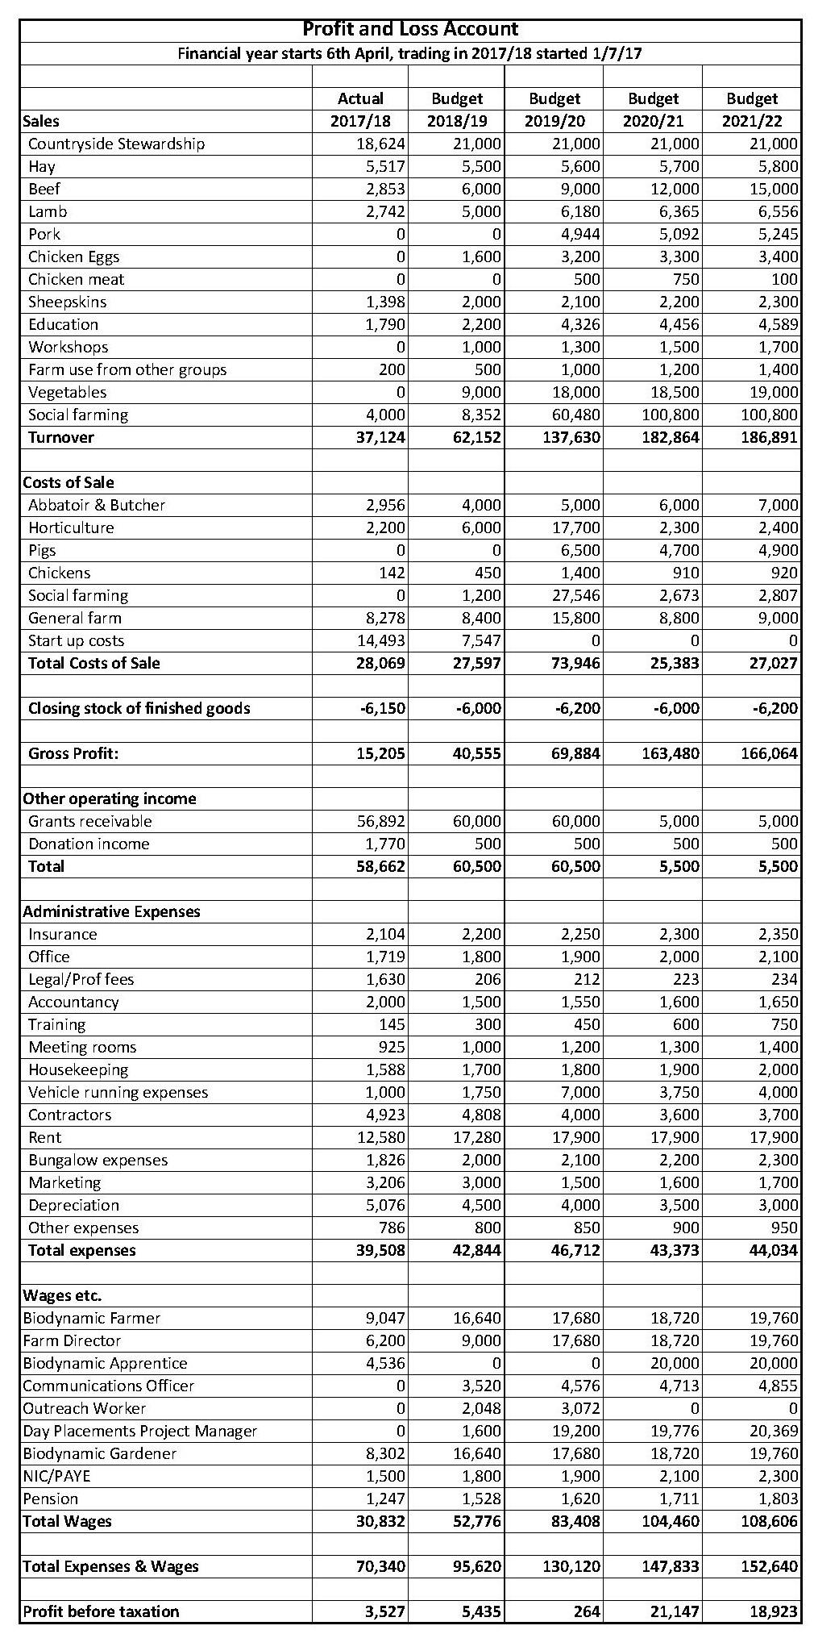

10.4 Assets
The table below shows the positive equity in the Society from year one actual figures to the next four years budgeted figures.
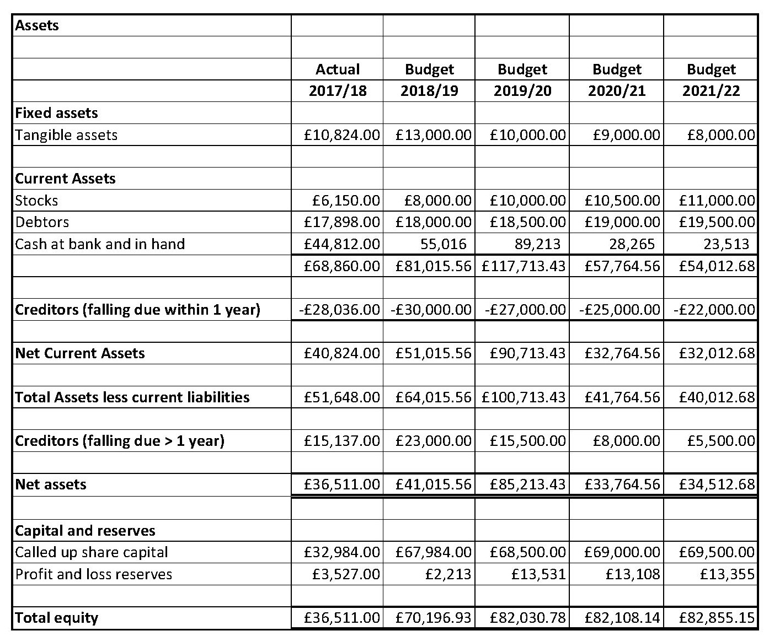

Net Current Assets

The Society has access to the existing herd of thirty-four Shetland cattle, two hundred and eighty North Ronaldsay sheep and three bee colonies the replacement value of which totals £14,800. These animals are all owned by Spencer Christy and a rental agreement will be drawn up in which he will lend these animals to the CCBS for an annual peppercorn rent. The CCBS will be fully responsible for the upkeep of these animals and have the ability to raise income from them through sales of meat, yarn and sheepskins.

10.5 Cash Flow

The initial set up period and phase two implementation show an erratic cash flow and then once the trading accounts for the income the cash becomes more stable.

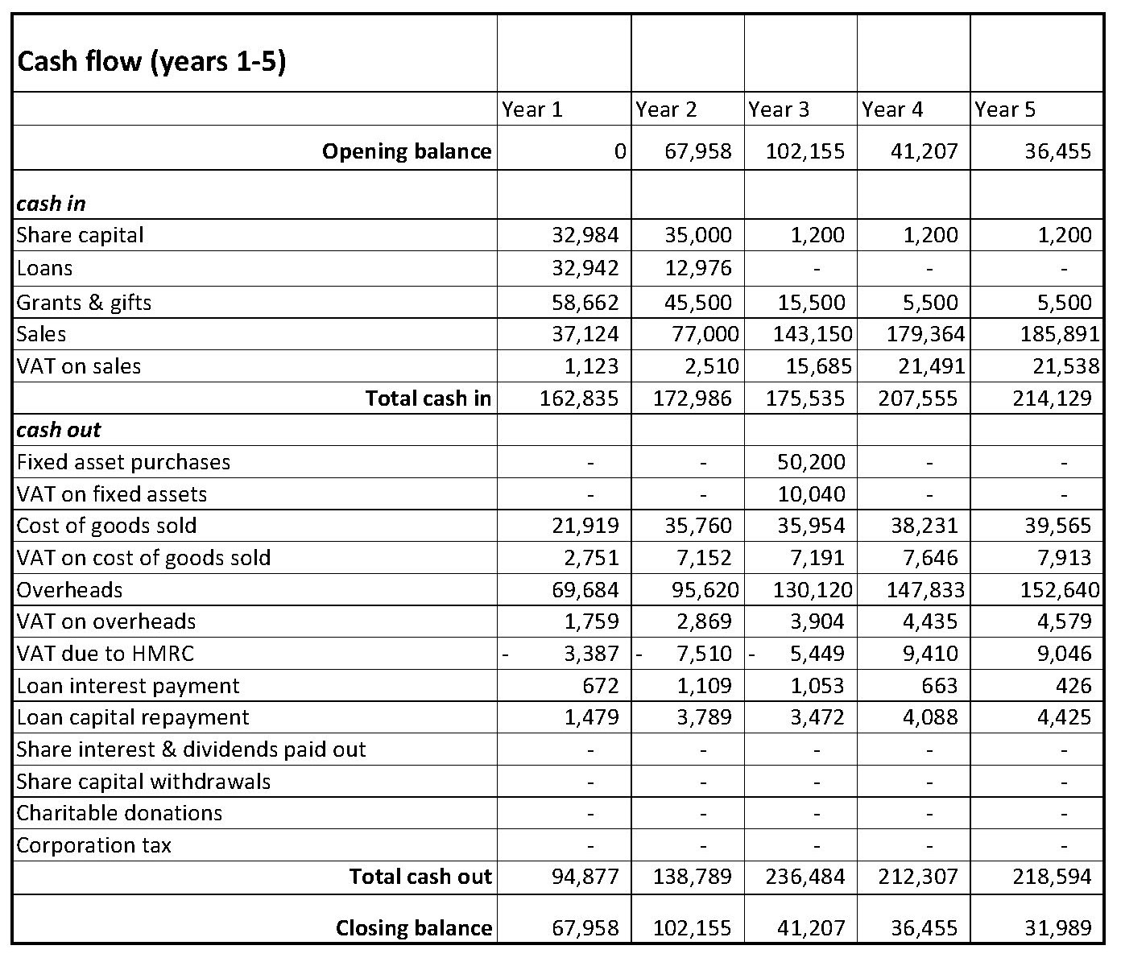

7. Phase II Share Offer and Fund Raising
Lauriston Farm Ltd is seeking to raise £35,000 by the issue of shares with a value of £1 each. In addition, we are looking to obtain £105,000 by way of grants and loans, and the share capital will act as the necessary match funding to lever these grants. Taken together these will cover the purchase price of capital items and provide the necessary working capital as described in the Finance section of this plan.
We are seeking the following funds:
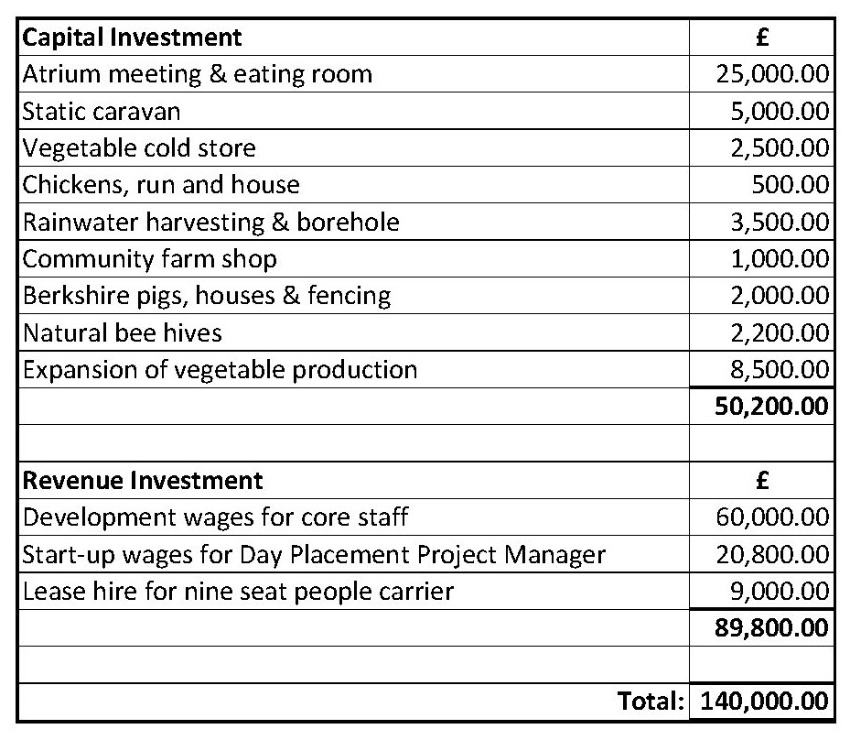
Share Offer
The share offer will run for five months from November 2018 to March 2019to and is designed to give our supporters the opportunity to contribute financially, on a long-term basis, to the business known as Lauriston Farm Ltd. We hope a good proportion of new shareholders will be generated by our existing shareholders and possible existing shareholders will increase their share ownership.
The value of each share will be £1, with a minimum subscription of 100 shares up to a maximum per individual of 750, i.e. £7,500. The purchase of a single share confers membership in the society. The value of a share in Lauriston Farm Ltd cannot increase beyond the nominal value of £1 and could even decrease if liabilities exceed assets.
The optimum amount we wish to raise from the share offer is £35,000, and the maximum amount is £80,000. We reserve the right to extend the share offer by a further four weeks but will keep investors fully informed.
If, within a reasonable time frame the offer does not reach the minimum target then the board will consider whether there is an alternative viable scheme – and investors will be consulted on this before their investment is drawn down.
Shares will be allocated on a first come, first served basis. These shares cannot be sold or transferred.
Interest Policy
The Society is obliged to re-invest profits not needed for the development of the business, for the benefit of the community, but it is also allowed to pay interest to its investors based on the amount invested.
We have assumed that no interest will be paid in the first five years. This investment must therefore be considered an opportunity to contribute financially to the community with the expectation of a social dividend rather than a financial reward. That is not to preclude the possibility, should profits allow and capital investment is not required and no other grant is offered to another local social business, at some stage in the future an interest rate will be proposed by the Board at the AGM and agreed by the membership.

Benefits of Ownership
The following benefits will apply for our shareholders:
- They will be part of a pioneering project for the locality, inspired by anthroposophy which brings together care for the environment through biodynamic farming and conservation with social farming initiatives for disadvantaged people and farm based education for all ages.
- They will be able to directly contribute though the volunteering program.
- They will be playing a vital part in ensuring the long term survival of this business as each activity helps to cross subsidise another, thus creating a resilient business model.
- There will be regular social and volunteering member’s days at the farm together with discounts available on all the farms revenue generating outputs including produce, workshops and crafts goods.
- They have the possibility of receiving interest on their investment
- They have the right to vote on the election of the directors and on all resolutions put to the Members by the Board, on the basis of one member one vote, no matter how large or small their shareholding.
- They can put themselves forward for election to the Board.

Share Liquidity
We hope that people will buy shares in Lauriston Farm as a long term investment, to keep the farm safe for future generations. However, people’s financial circumstances might change and they may wish to withdraw their funds from the Society.
The first Management Board is stipulating that in order to ensure that the Society has time to make a profit and build up some financial reserves, shareholders will not be able to withdraw capital within the first three years, except in exceptional circumstances, after which time they can apply in writing according to the Rules of the Society. The board will also have the right to set a cap on how many shares can be withdrawn each year. In the event of the death of a member, the intention would be to make an earlier repayment, if requested, subject to funds being available.
The Board will consider all such requests in the order in which they are submitted, but they are obliged to consider the financial security of the Society. If withdrawing shares would leave the Society unable to meet its financial commitments, and result in inadequate level of financial reserves, the Board will have to suspend withdrawal of shares. This does not preclude the possibility of future applications succeeding, when more cash has become available.
Dissolution
Should Lauriston Farm cease trading, leading to the necessary sale of assets, any surplus (after paying creditors and repaying share capital) must be used for the benefit of the community. Any shortfall will mean the amount returned to each shareholder will be scaled down pro rata.
As Lauriston Farm Ltd has limited liability, then should it fail, there would be no further liability on shareholders beyond the nominal value of their shares.
Risks
Anyone considering investments should think carefully about the risks involved. This share offer is exempt from the Financial Services and Markets Act 2000 or subsidiary regulations, which means there is no right of complaint to the Financial Ombudsman, nor a right to apply to the Financial Services Compensation Scheme.

8. Making it happen

November 2018 –Launch Phase II share offer and general fundraising
December 2018 – employ Day Placement outreach worker
April 2018 – twelve day placements filled, Day Placements Project Manager starts
May 2019-Septmeber 2019 – install capital items from fundraising
April 2019 – all 35 day placements filled
Annex 4: Photographs
Pic.1: Farm House and Brick Barn
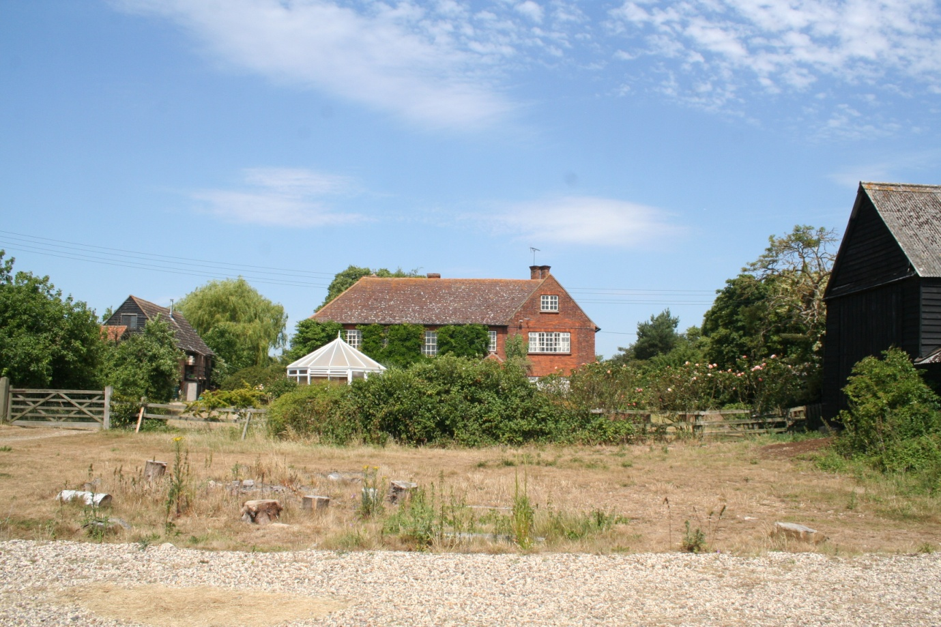
Pic.2: Farm Buildings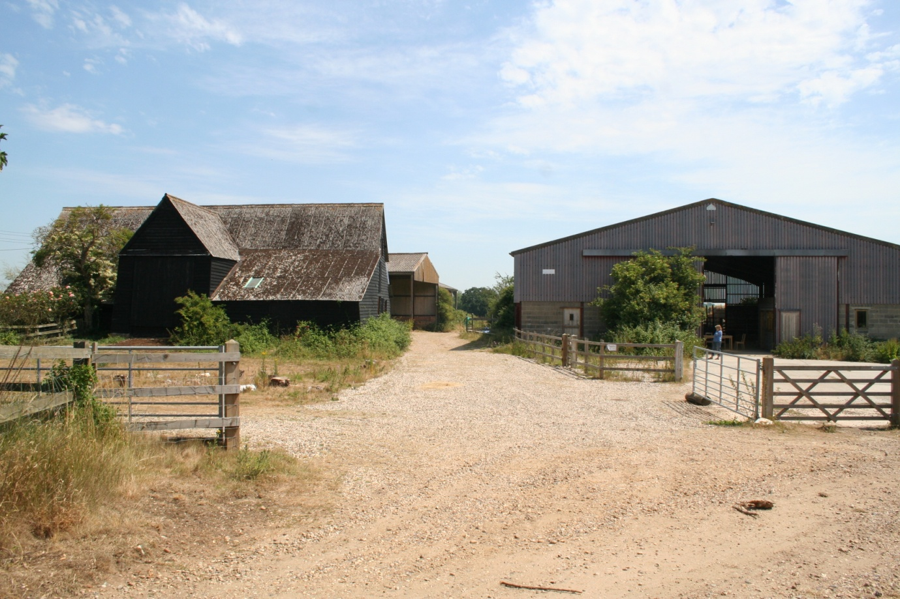
Pic.3: The Farm Land looking North from sea wall showing sea meadow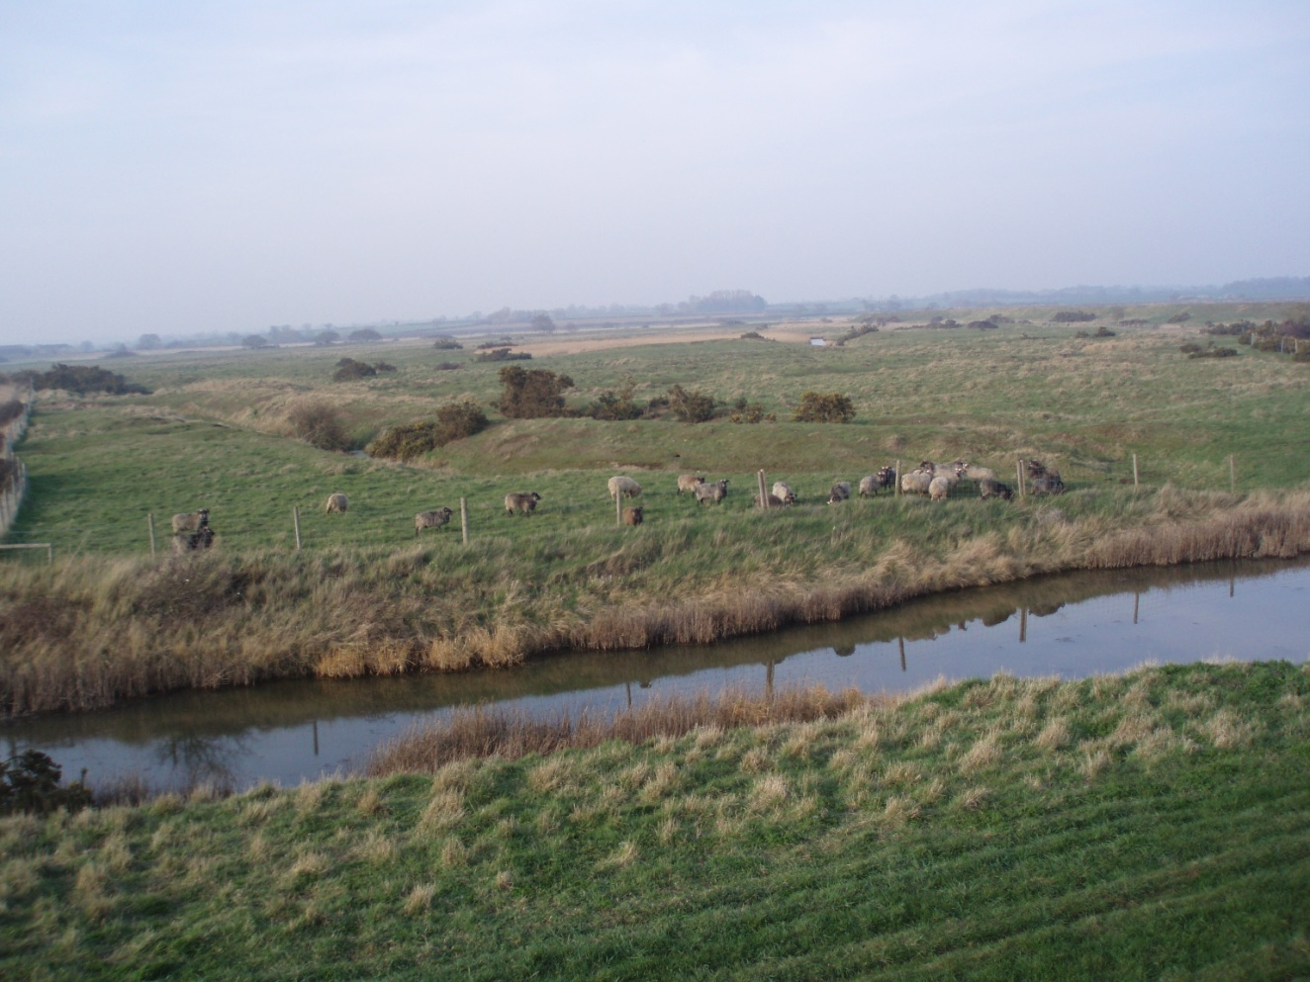
Pic.4: The Gore Salt Marsh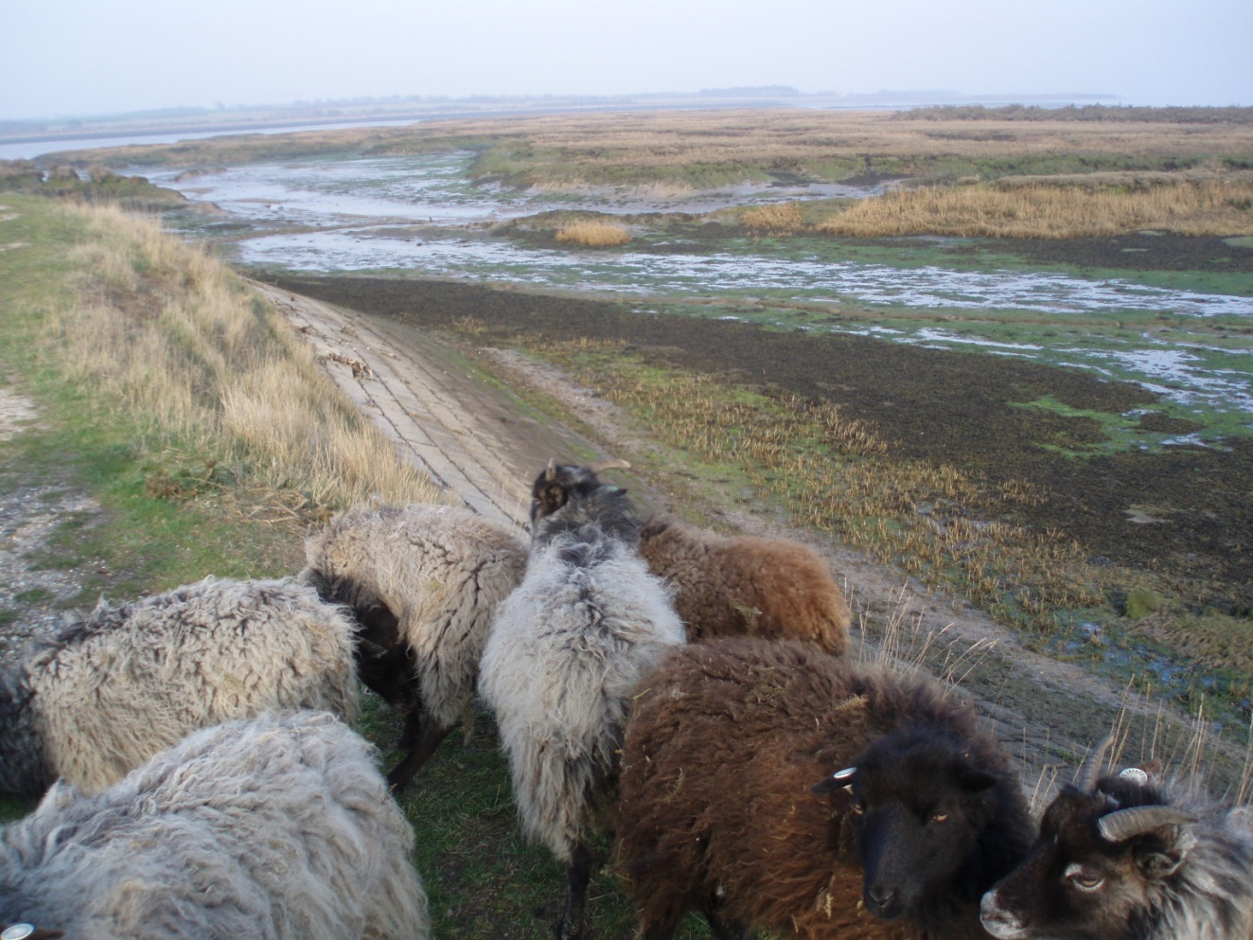
Pic.5: Duncan, Shetland Bull
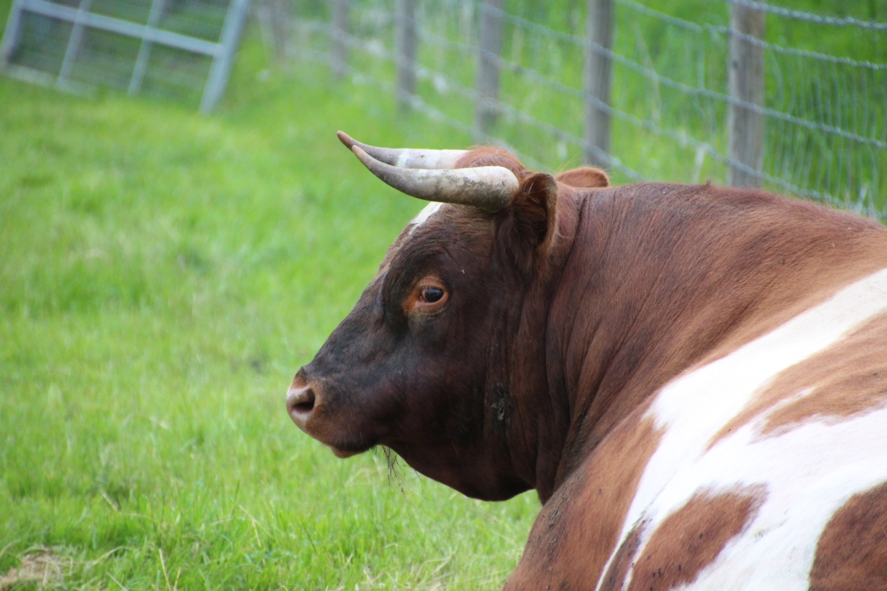
Pic.6: Samantha with new born calf, Atlas, and one year old heifer, Chestnut
